Mobile Application Development

Assignment 3.

18309003 Roh sung ho

18309008 Nabil Madih

Function 1. Main page < NOTICE Function >

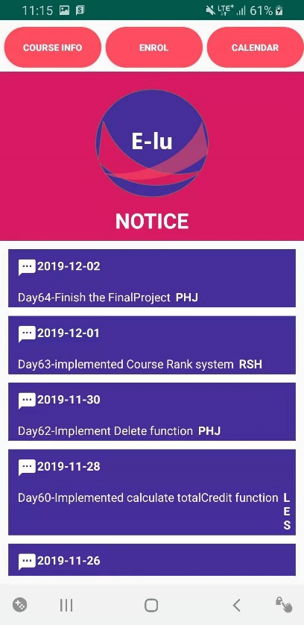

There is a Main page, and we implemented the notice function using the PHP, MySQL.

It is a Dynamically controlled by the number of Data in the Database server.

Here is a PHP, Java file, which can connect between MySQL server and our Application.

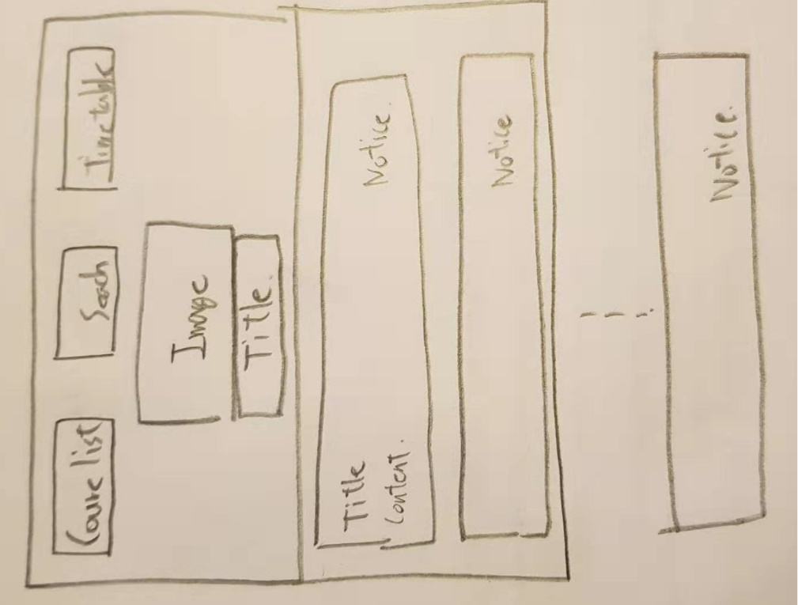

Here is a first design.

Function 2. Make the Timetable Function.

Make the Time table form. Using JAVA.

There will be input from my database sever. So we made the day cells.

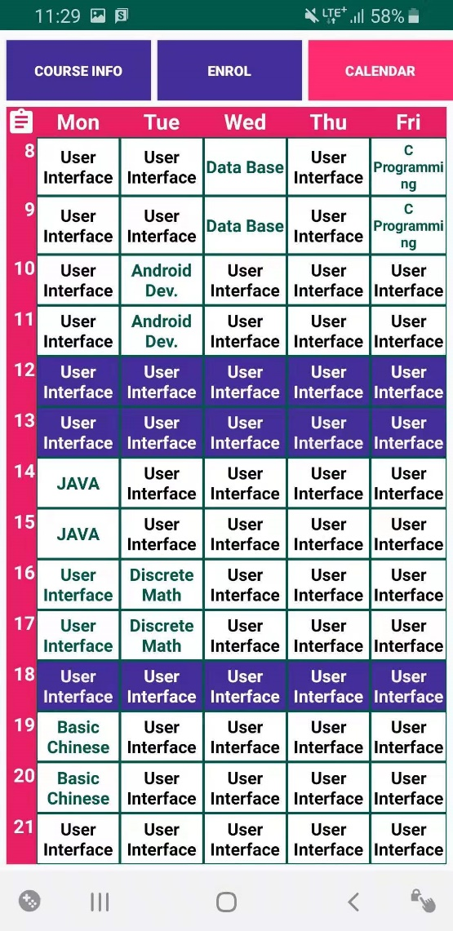

Also we can check that is a good form.

And now we made the PHP file for connect between Application and MySQL server.

There is a schedule table, When we added the Course in the CourseList page.

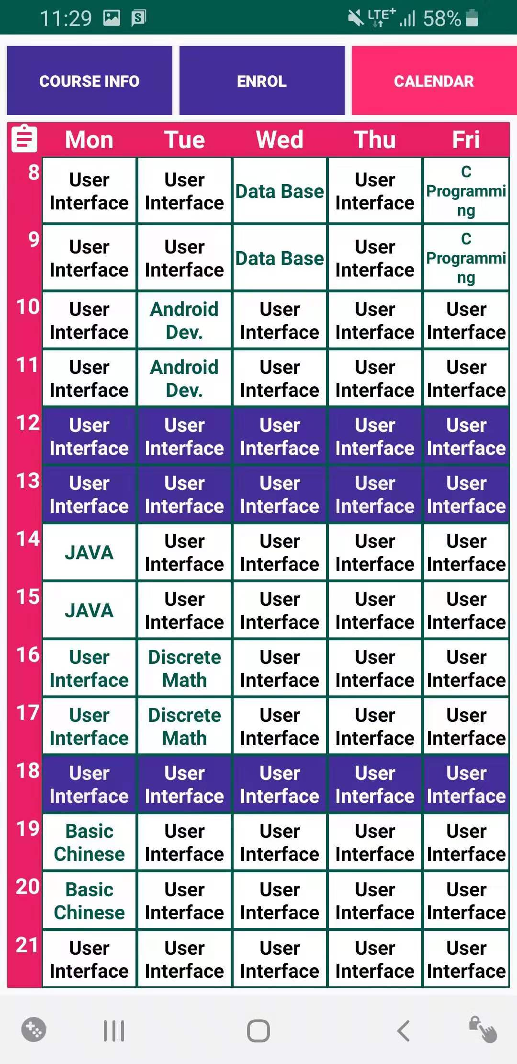

Result.